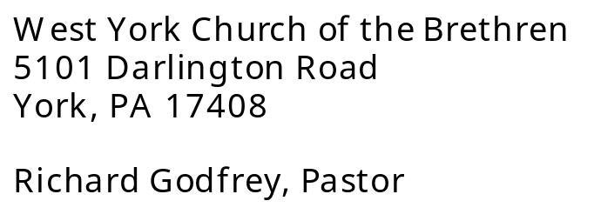



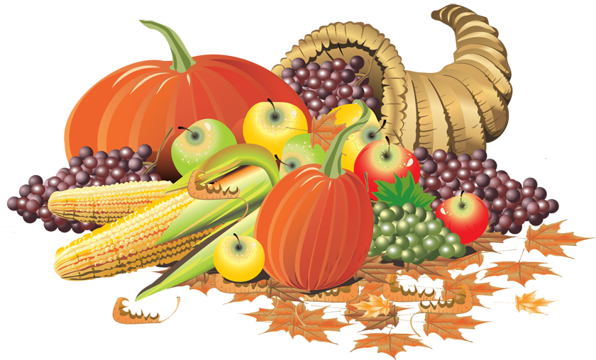

November 2026
“The mission of the West York Church of the Brethren is to love, nurture and build the community of Jesus Christ.”

“The mission of the West York Church of the Brethren is to love, nurture and build the community of Jesus Christ.”
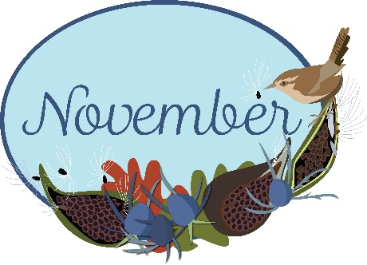
November’s Newsletter is in memory of Lillian, Glenn & Jim Brenner.
UPCOMING EVENTS:
All Saint’s Day – November 1st
Daylight Saving Time Ends – November 1st
Men’s Breakfast – November 7th
Veteran’s Day – November 11th
Newsletter Deadline – November 16th
Knitting/Crocheting Ministry – November 16th
Day of Prayer for Children & Youth – November 18th
Christ the King Sunday – November 22nd
Thanksgiving Day – November 26th
Thanksgiving Dinner Pickup – November 26th
1st Sunday in Advent – November 29th
November 1st
Don’t forget to turn your clocks back!
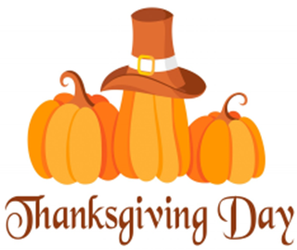 THANKSGIVING DAY MEAL
TAKE-OUT ONLY
Thanksgiving Meal on
Thanksgiving Day, November 26th.
PICK-UP TIME IS 11:00 AM TO 1:00 PM.
Meal will consist of: Turkey, filling, mashed potatoes, gravy, sweet potatoes, corn,
green beans & dessert.
This is a free meal but you will need to make reservations for the number of meals you need.
Deadline to sign up is Friday, November 20th.
PLEASE SIGN UP ON THE SHEET HANGING AT THE MAIN ENTRANCE.

WE ARE ALSO LOOKING FOR DONATIONS OF TURKEYS. SEE THE SIGN-UP FOR HELP, ETC.



SINGERS NEEDED
We will be presenting the cantata
“Rejoice with Great Joy”
during the 10:15 am worship service on Sunday, December 20th.
We are in need of singers to help present this cantata. Practice will be held Thursday evenings at 6:30 pm starting November 5th.
Contact Beth Marshall if you are able to help.

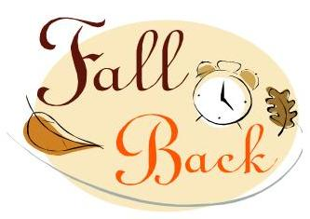
The West Yorker
West York Church of the Brethren
5101 Darlington Road
York, PA 17408
Phone: (717) 792-9260
Prayer Line: (717) 792-9260 (Option “5”)
E-mail: westyorkchurch@gmail.com
Website: www.westyorkcob.org
Sunday Worship: Sunday School 9:00 am
Worship Service 10:15 am
2026
November 2026 Page 2


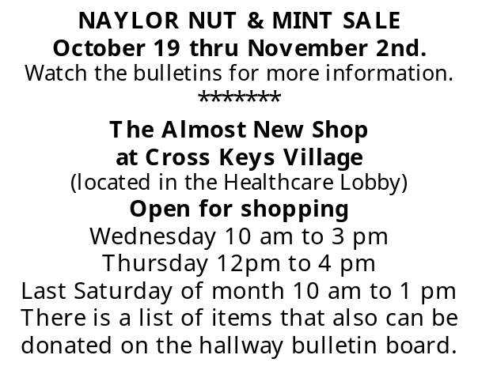

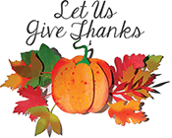

Carlisle Truck Stop Ministry
Cookie Collection

WE WILL NOT BE DOING ANY ON SITE BAKING OF COOKIES for Carlisle Truck Stop Ministry this year. You can bring donations of home baked cookies. At the request of the Truck Stop Ministry all cookies are to be home made.

Feel free to donate money for ingredients if you are unable to make cookies.

NOTE: They are asking you to wear gloves (masks are optional) while preparing and packaging cookies, and that you seal the bags with staples, bows, etc.

Bring your cookie donations to church by
Sunday, December 6th. We will be assembling/bagging the cookies after church that day. Any questions, please contact Brenda Myers. Sign-up sheet will be hanging at the main entrance.


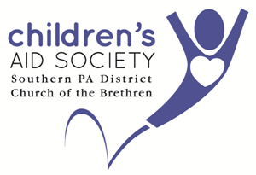
SAVE THE DATE!!
REACHING FOR THE STARS
Tuesday, November 17th, 2026
Yorktowne Hotel
For more information go to cassd.org.
**********
All three centers need paper goods - paper towels, Kleenex, wipes, toilet paper, paper plates, copying paper and construction paper. When these items are donated it saves us money because we don’t have to buy them.
Thank you for your continued support for CAS.

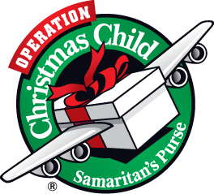
Operation Christmas Child

Operation Christmas Child shoeboxes are available now. Let’s send the love of Jesus to the children of the world!

A list of gift suggestions is available on the table in the gathering area.

Completed boxes need to be returned to the church no later than NOVEMBER 15th!!


In the event of bad weather, please contact Larry Marshall
for cancellations.
We will once again have a
Mitten Tree
this year. Please bring mittens, hats, gloves, scarves and socks to put on the tree.


DECORATING FOR CHRISTMAS
We will be decorating the church for the Christmas season on
Friday, November 27th at 6 pm.
Please notify Wanda Keefer if you can help!



MEN’S PRAYER BREAKFAST
Saturday, September 12th 8 am
Fellowship Hall at WYCOB
PLEASE JOIN US!!!
POINSETTIA ORDERS
The form for ordering poinsettias is on the table in the Gathering Area at church or you can call the church office. Deadline to order is Sunday, November 15th. We will also have the alternative giving to honor or memorialize someone, and the money goes to our benevolence fund instead of buying a flower.

November Special Offering
Our special offering for October is

“Stewards”
(Property and Grounds)
This offering is deposited to the
Equipment Replacement Fund.
Please use the brown envelopes on the table in the gathering area.

December Newsletter
the deadline for articles for the
December Newsletter is
November 21, 2026
For the next few months, we will be collecting donations for the Thanksgiving and Christmas food giveaways for the Harvest of Hope Food Pantry. They are asking for the following donations: Boxed Potatoes, Boxed Stuffing, Cranberry Sauce, Gravy. Other items may be added later.
HARVEST OF HOPE FOOD PANTRY
4485 Wolf’s Church Road, York, PA 17408
717-702-6070
Tues/Thurs starting at 5 pm
Wednesday starting at 12 pm

November 2026 Page 3



INVITATION TO SUNDAY SCHOOL
The “Seeking Amazing Grace” Adult Sunday School class continues to grow, numerically, but even more importantly, spiritually. We have studied - in depth - the prophetic books of Revelation, Daniel and Isaiah, as well as the exciting Gospel of John. We our currently studying the book of Genesis.
You do not have to be an advanced Bible scholar to be a part of this class - only someone interested in learning more about God’s Word - the Bible - and how it applies to our modern-day culture.. Please come and check us out.
Bible study is one of the most important aspects of a growing, maturing faith, and is ever-increasingly important in these chaotic times in which we live. And the informal, friendly atmosphere of the Sunday School class is a great place to see God’s Word come alive in your own life and walk of faith. Come join us.
We also continue to look at the Wired Word - a study of the current top news stories of the week and how Scripture applies to those stories and how we, as Christians, need to respond to the events in the news each day. Hope to see you in class.

Care and Share Women’s Bible Study meets virtually on Mondays at 7 pm, led by Judith Wallace. They are currently studying
“Matthew: The Arrival of the King.”

You are invited to join one or more of these groups for Bible Study!!

CHARITY KNITTNG/CROCHETING MINISTRY
We meet the 3rd Monday of each month from 10 am to 12 noon. Anyone may participate, even if you can’t meet in person. Some of the suggested ideas are prayer shawls, chemo hats, homeless hats, etc.
Please see Brenda Myers if you have questions.
November 2026 Page 4



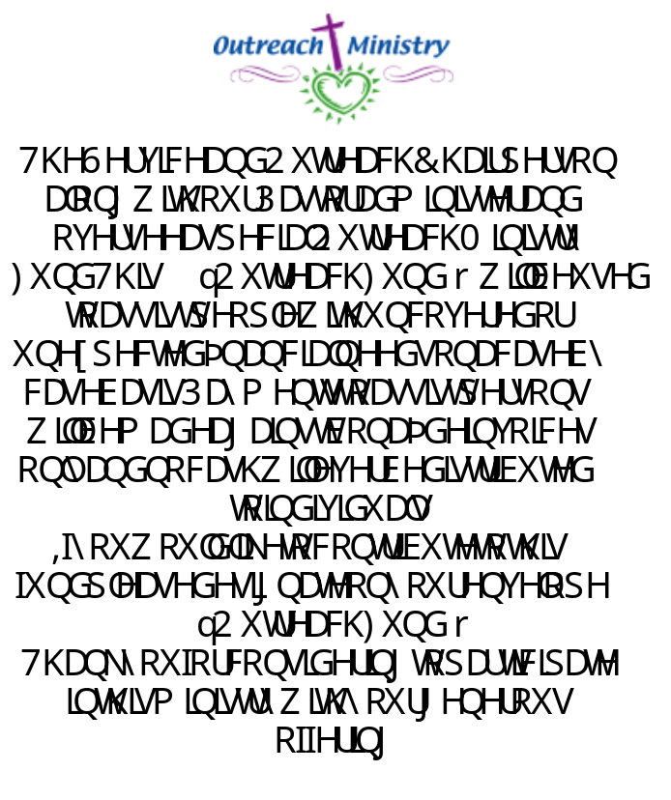

November 2026 Page 5
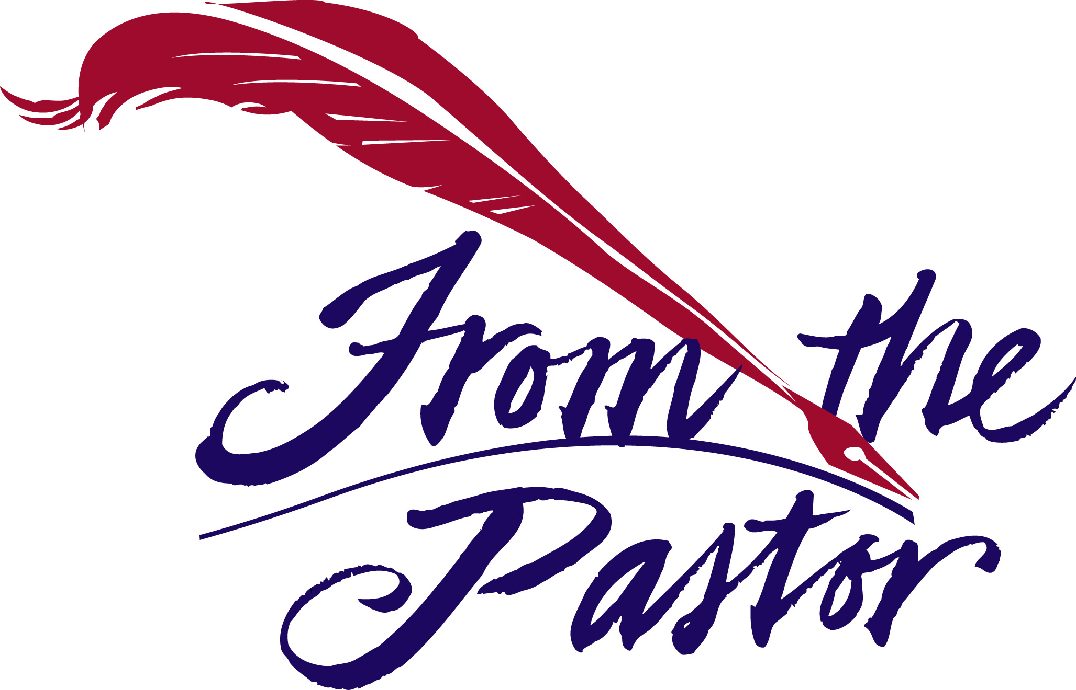

“And he (the prodigal son) arose and came to his father. But when he was still a long way off, his father saw him and had compassion on him, and ran and fell on his neck and kissed him.”
Luke 15:20

John Newton’s hymn Amazing Grace contains these familiar words: “I once was lost but now am found, was blind but now I see.” The reference to seeing is taken from the story of the blind man Jesus healed (John 9:25), whereas the reference to being found is taken from the parable of the prodigal son (Luke 15:24).

Jesus’ parable of the Prodigal Son is one of the most poignant in the four Gospels. It is a story of mercy – the story of an undeserving son who received the compassion of his father after abusing his privileges as a son. Though the son deserved the father’s judgment, he received the opposite: love, forgiveness, reconciliation, and reunion. Whenever judgment is replaced by mercy, there is a price to be paid if reunion is to be realized.

If there has been a break in one of your relationships with a friend or family member, consider paying the price of extending mercy. Such a reunion demonstrates what God has done for each one of us.

Pastor Godfrey

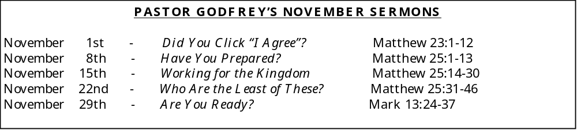

November 2026 Page 6

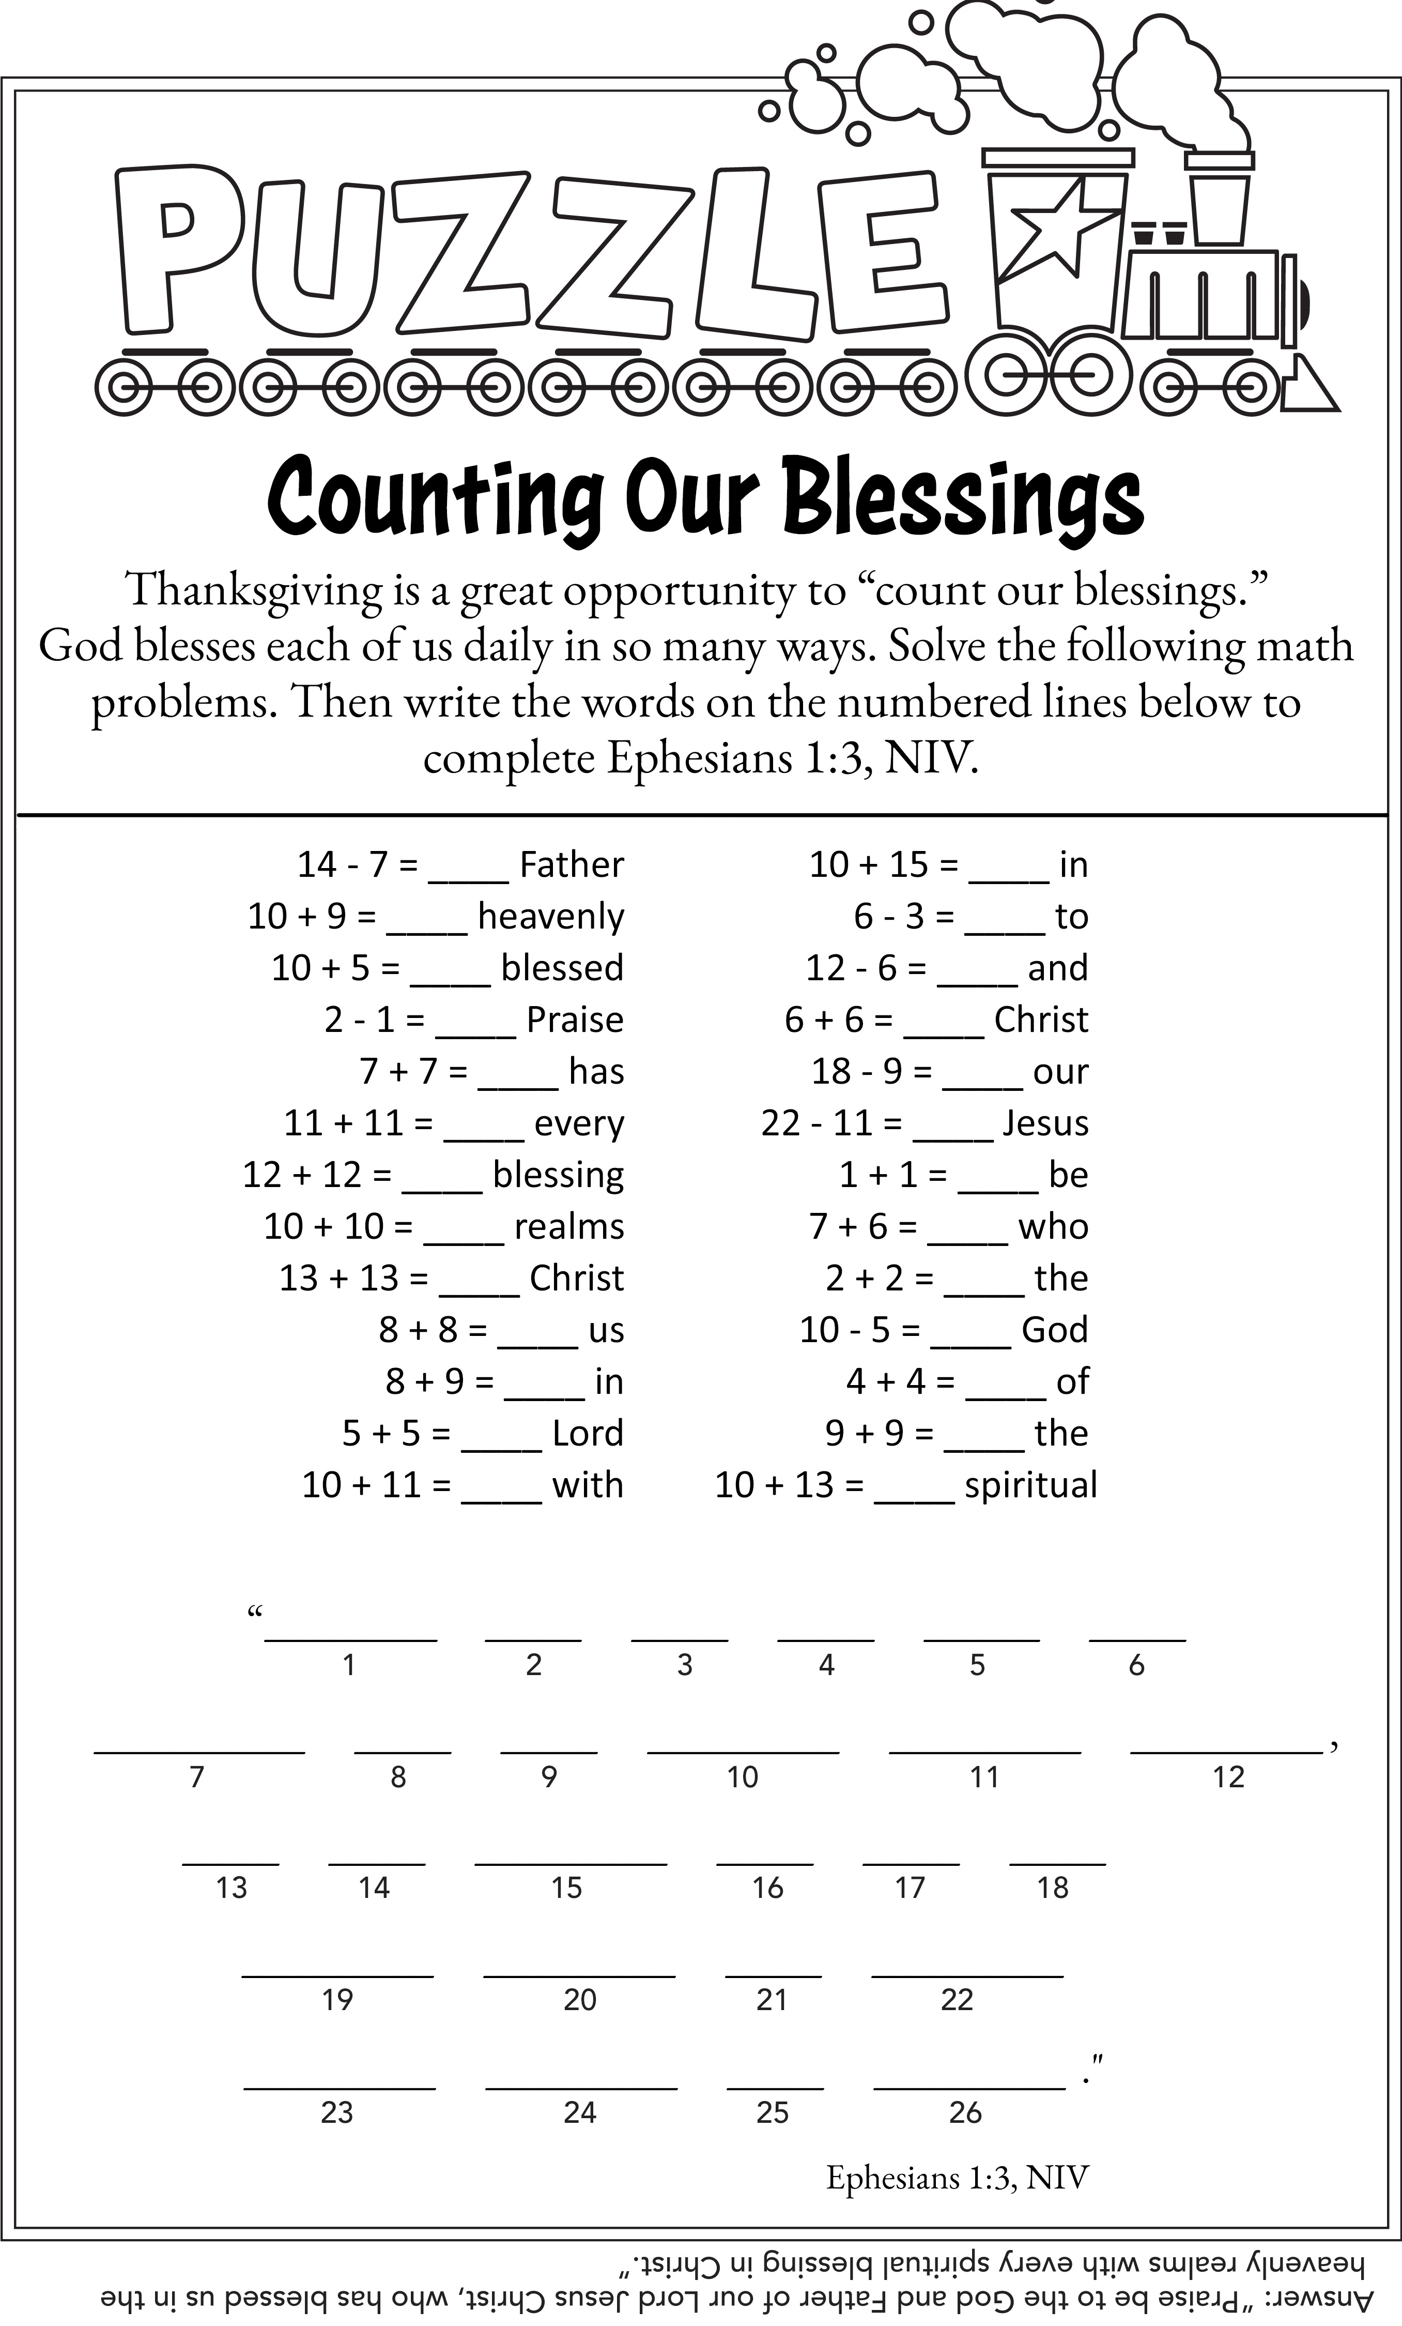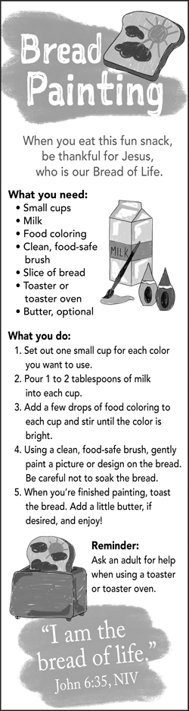

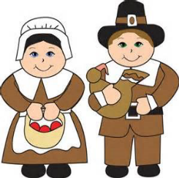

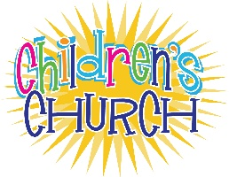

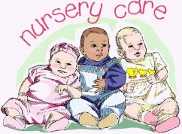
CHILDREN’S STORY

If anyone feels led to share a Children’s Story during the Worship service please let Pastor Godfrey or Barb in the office know.

CHILDREN’S CHURCH
meets during the
worship service each week.

IF YOU ARE CERITFIED IN CPR & AED, PLEASE CONTACT BARB IN THE CHURCH OFFICE AND LET HER KNOW. WE ARE COMPILING A LIST OF THOSE WHO ARE TRAINED IN CASE OF AN EMERGENCY.

THANK YOU!!

THE NURSERY IS AVAILABLE FOR CHILDREN FROM NEWBORN THROUGH
3 YEARS OLD. IT IS LOCATED IN THE ROOM OFF OF THE GATHERING AREA.
November 2026 Page 7
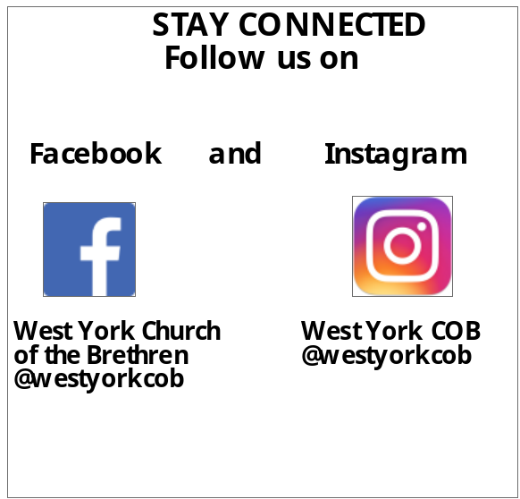

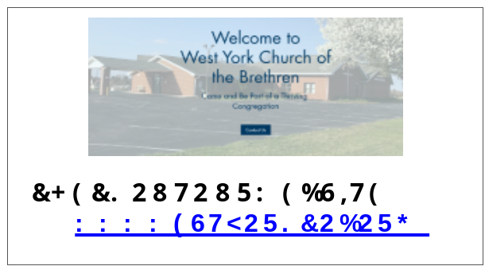



Acolytes
1 Caleb Grove
8 Eva Hake
15 Alex Bridges
22 Isabelle McMonigle
29 Caleb Grove

Greeters
1 Kathy Hinkle
8 Cheryl Fahringer
15 Darlis Parker
22 Brittany Nolt
29 Pat Eutzy

Power Point Operator
1 Dave Highlands
8 Larry Marshall
15 Nathan Keefer
22 Bill Zumbrum
29 Dave Highlands

Sound Board Operator
1 Gary Hake
8 Matt Osborne
15 Ed Jacobs
22 Merl Keefer
29 Gary Hake

Nursery Caregivers
1 Nicole Grove
8 Kayla Eshelman
15 Genie Grove
22 Vivian Hubble
29 Jessica McIntyre

Hospitality Table
1 Susan Parente
8 Linda Zumbrum
15 Linda Fulmele
22 OPEN
29 OPEN

November

Ken Miller
Glenn & Jane Miller
Courtney Hershey Jacob Greiner
Kiersten Greiner
Nicole Grove
Jack Kurtz
Eli Grove
Evagene Hake
Emily Daley
Lillian Grove
Joann Rohrbaugh
Bryan Bricker
Tara Hoover
John Grove
Carley McDowell
Carson Marshall
John & Shirley Grove
Beth Marshall
Xavier Torres
Earl & Sandy Hoover
Adalei Marshall
Caleb Hershey

Serving our Congregation in November
November 2026 Page 8

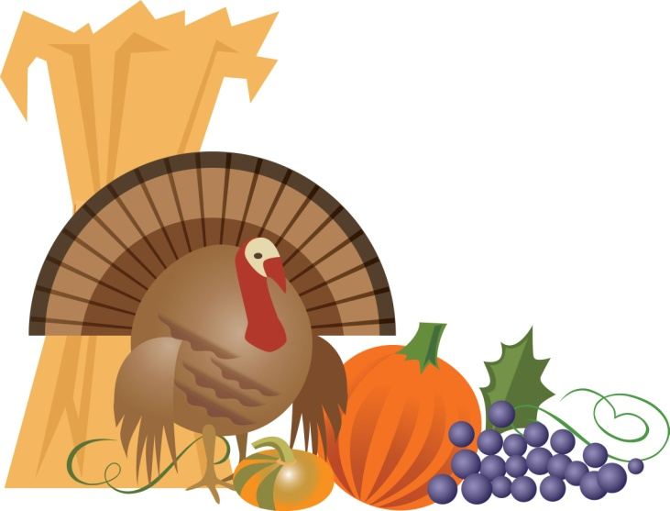
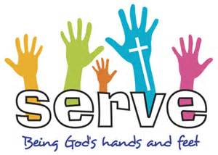



Thank you so much for all the cards I received for my birthday. What a great surprise!
The notes included in the cards brought tears to my eyes. I am truly blessed to be here and serve as your Church Secretary.
Barb Sloat
********
Your continued generosity to Children’s Aid Society is a powerful reflection of your compassion for the children & families we are honored to serve. We are sincerely grateful to acknowledge your recent gift of $562.50 & your continued commitment to our mission to empower children & their families to build stronger, healthier lives.
Eric Chase, President/CEO
********
Thank you West York for bringing the truth of the Gospel to the men and women we serve.
Matt Hershey
Jubilee Ministries
Prayer Requests
If you have a prayer request you would like to share with the church, please fill out a prayer card (found in the gathering area) and give it to the pastor. You may also call Barb in the church office.
For pastoral emergencies:
Please contact Pastor Godfrey
or Cindy Heist.

Gifts Discernment Team
We are looking for persons to fill the following open positions for 2027.
• 1 person for the Gifts Discernment Team
• 1 delegate for Annual Conference
(July 28 thru Aug 1 – Daytona Beach, Florida)
• 1 delegate for District Conference
(September 17 & 18 - Greencastle COB)

If you are interested in any of these positions, please contact Joyce Whitcraft, Nathan Keefer, Michelle Hartlaub or Ron Horn, Jr.
DAY OF PRAYER FOR
CHILDREN AND YOUTH
Wednesday, November 18th is our monthly Day of Prayer for our Children and Youth. Please find time during this day to pray for our Church’s Ministry to Children and Youth.

The Wellspan Spiritual Care and Education Department wants to let our church know when a member is in the hospital. PLEASE identify our church at registration and admittance into the hospital. According to HIPAA regulations, if you provide this information to the hospital, our church may be notified of the admission.
November 2026 Page 9

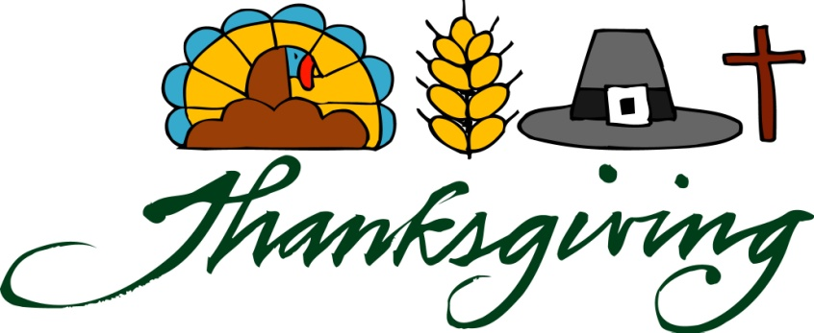


SENIOR DAY
Wednesday, November 4th
9:30 am Meet & Greet w/continental breakfast
10:00 Morning Program
12:00 pm Delicious Lunch
1:00 pm Dismissal

We are approaching cookie season!
We will be doing fall themed cookie decorating that the senior will be able to take home
and a post card activity about camp/camping memories!
Cost: $20.00
Register online at Campeder.org or call the office at 717-642-8256.
******
CHRISTMAS TREE FESTIVAL
December 11th & 12th 5 pm to 8 pm
Join us in celebrating the King!
Christmas Lights & Music ⁓ Decorated Trees
Tree Decorating Contest ⁓ Bake Sale
Kid’s Activities ⁓ Cozy Fires
Luminary Garden (Honoring our Loved Ones)
Delicious Turkey Dinner & Soup (per donation)
Warm Drinks & Cookies (Free)
Hay Rides Friday & Saturday 5-9 pm
(See the poster hanging at the main entrance)

November 2026 Page 10

